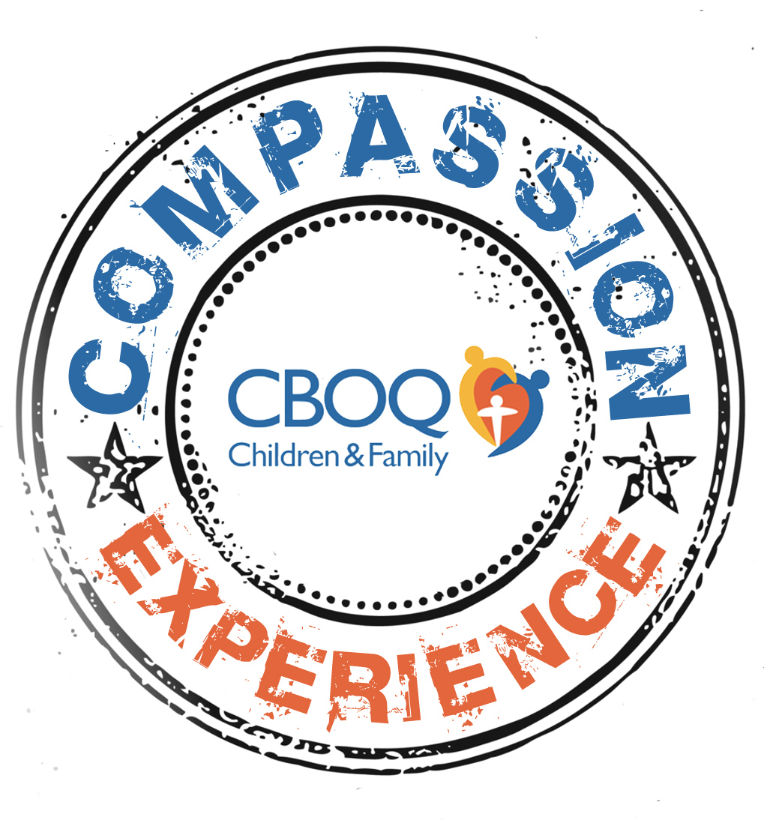
Family Compassion Experience: Dominican Republic
December 26, 2014–January 2, 2015
Cost: $1750/person

Dear Ministry Partner and Parents:
CBOQ Children and Family Ministries exists to serve God by developing and mobilizing frontline children and family ministry leaders across Ontario and Quebec in partnership with Christian family agencies in engaging children and empowering families to reach their God-given potential. One key avenue we intend to engage children and empower families to reach their God-given potential is through providing a family compassion experience (known to many as short-term missions trip).
Why a Family-based Compassion Experience?
In our western culture of prosperity and instant gratification children are growing up adapting very easily to a comfortable lifestyle. An opportunity where they are able to develop an awareness of and concern for a hurting world beyond their comfortable lives alongside those who have the greatest influence on them, their family, is something invaluable in seeing them become counter-cultural. This experience won’t result in an instant change but this is one of the interactive learning elements for children, along with their parents to see the world “beyond their backyard”, engage with another culture and become aware of the world. Through this kind of experience they can learn what it means to be part of making a kingdom difference. There may not be a quantifiable return on financial investment as this experience is one to be viewed from an eternal long-term vantage point. Done wrong it can be damaging, but done right it can have a ripple effect that doesn’t end.
Benefits
- Families are strengthened when they serve together.
- It begins to foster a missional mindset in today’s children early on
- Families see and begin to understand together the needs of others.
- Families set an example for one another.
- Families develop a heart for people to know God’s love.
We are excited to be offering this new opportunity, in partnership with Careforce International in 2014. This registration package outlines some details to get you started in the application process.
We thank you for considering partnering with us as we see God transform both the communities we are coming alongside as well as your family.

Serving You in Christ’s Name,
CBOQ Children and Family Ministries
APPLICATION PROCESS
LEADING UP TO YOUR APPLICATION…
- Read this package and be familiar with its contents.
- Pray for everything leading up to, during and after CE-DR as a family.
- Complete the family application form along with a $200 per person deposit fee (payable to Careforce International) before Friday, May 30, 2014. *Please note, we will be accepting a maximum of 5 families for this experience. The application fee will only be processed if your application is accepted. This deposit fee will be applied to the total registration fee.
- You will receive confirmation by June 3, 2014 about your family’s acceptance status.

AFTER YOU RECEIVE ACCEPTANCE
- Once you’ve received confirmation of acceptance, you will receive a manual, which will contain additional details, forms from International Teams Canada, and introduction to your Compassion Coordinator.
- All individual applications are due by Tuesday, June 10, 2014 and should be mailed to CBOQ.
- Your manual will contain details for preparing as a family spiritually, fundraising, learning about DR and the project as well as a copy of the book, Don’t Forget to Pack the Kids Short Term Missions for Your Whole Family, by Jill Richardson.
- On Saturday, September 20, 2014 @ the CBOQ office (304 The East Mall, Etobicoke), there will be an orientation and training day. You will have the opportunity to meet the other families participating. Children and parents are both invited to this day.
- The team will gather together on the evening of Thursday, December 25, 2014 at a hotel near the airport. The team will leave on Friday, December 26, 2014 and return on Friday, January 2, 2015.
THINGS TO KNOW!
Financial Details
CE-DR is a ministry of CBOQ Children and Family in partnership with International Teams Canada and Careforce International. The cost to carry out this project is $1750 per person including all materials, orientation, accommodations, DR transportation, flights and travel medical insurance. (Does not include passport, vaccinations, etc.)
Note that this is not a registration fee but the cost to carry out the program. All donations are allocated to the program, not the individual; therefore there are no “refunds.” In the event that there are surplus funds, they will be directed towards the DR Project.
All financial payments for the project can be made by cheque payable to Careforce International.

Please read through the F.A.Q. page to find out more details, including what the week will include, where you will stay, safety, expectations, etc.
ABOUT THE LIGHTHOUSE PROJECTS
Lighthouse Protects is an outreach ministry that cares greatly about the needs of the local people. It is currently located in Los Alcarrizos, a community of over 312,000 people about 30 minutes north-west of Santo Domingo, the capital city of the Dominican Republic.

Our main focus as a ministry is education. Through the Russel Van Vleet school and vocational center we serve over 1,000 children and youth from preschool-12th grade. As a part of enrollment the neediest of these children also receive a nutritional breakfast. More than 300 youth and adults participate in our training programs, in the areas of computers, electricity, auto mechanics, beauty salon, marketing and ESL. In addition we serve the community through a water purification plant with a capacity of producing 25,000 gallons daily that provides safe drinking water at a discounted cost. We also do construction in the community including the building of homes for poor families, playgrounds, basketball courts, sidewalks, curbs, etc. All of this is a way to help the immediate needs of the community, which allows us to earn the right to share the Gospel of Jesus Christ with them. These ministries are done primarily through the help of volunteers from the U.S. and Canada.
Discover more about this ministry by visiting the facebook page “Lighthouse Projects” or Careforce at www.careforceinternational.ca
CE-DR Family Application Form
Due Date: Friday, May 30, 2014

Parent Name(s): __________________________________________________
Church: _________________________________________________________
Home Phone Number: _____________________________________________
Email Address: ___________________________________________________
Children’s Name and Ages:
Name: _______________________________________ Age: _________
Name: _______________________________________ Age: _________
Name: _______________________________________ Age: _________
Name: _______________________________________ Age: _________
Share 2-3 points of why your family wants to participate in CE-DR? (Please use another page if needed)

Please submit this form before Friday, May 30 by
Mail: 100-304 The East Mall, Toronto, ON M9B 6E2
Fax: 416-622-2308
Email: tyuen@baptist.ca

F.A.Q. for Family Compassion Experience
What constitutes family?
We are committed to building compassion-minded families, so whoever makes up your family is welcome to join this experience. This could include a husband and wife with their children, a single parent and child, a grandparent and grandchild, etc.
How do I know if my family is ready for this kind of experience?
If you desire to make a difference for Christ and your children are ready for an adventure, then God can work through your family! There are no specific gifts or skills required, but rather a willing and obedient spirit.
How old do my children need to be?
This is something determined by you as you know your children best! The experience is designed to include children as young as 4 in meaningful ways. Children younger than 4 may require care that prohibits participation in the full experience.
What will be my child’s role?
Children are full participants in this experience. The daily work project will include tasks that young children can fully participate in alongside adults.
What will we do?
The experience will include a work project, ministry outreach, learning about the country and worship with a local church. Each day families will spend the morning on the work project. The main tasks will include things such as painting and tying rebar. The afternoons will consist of ministry outreach. This will include opportunities of going out into the community to meet families through leading games, face painting and sharing about your life and also hosting families for similar types of activities and swimming at the LightHouse Compound. There will also be some afternoons where we will travel into the city and visit some historical sites and learn about the country. Evenings will be free for family time, rest, etc.
What will our accommodations be like?
Each family will stay in their own private room with en suite washroom in the dormitory building. The building has hot water and is air conditioned. It also has a recreation/play room for children.
Is this safe for my children?
Safety is of utmost importance. The LightHouse Project’s main facility is on a secure compound. Our project partners and your team leader will take every precaution to ensure that the entire experience is safe for you and your family.
What will the food be like?
Food provided during the team experience is prepared by the local partners with regular input from International Teams Canada personnel. The menu is designed to provide balanced meals using locally purchased ingredients and takes into consideration North American diet. All food is prepared with a high health and safety standard. The water at the project site is clean, safe drinking water. Purchasing food from street vendors is discouraged unless the local host has made special arrangements or indicated it is safe.
What expectations do you have of parents?
We expect that you will read all materials provided and be aware of all deadlines for forms, payments, etc. We expect that you will invest the time needed to prepare for this experience as a family and any particular ways you may need to prepare your children. This may include using the materials provided for training.
What training and/or resources will I receive?
Upon acceptance to the team, you will receive a binder containing information about the experience as well as ideas for preparing as a family. You will also receive a copy of the book, Don’t Forget to Pack the Kids Short Term Missions for Your Whole Family by Jill Richardson. Your family will be required to attend the Orientation and Training Day on September 20.
Is it really possible for my family to raise the funds necessary?
Yes! One of the first, and perhaps greatest lessons that can be learned on an experience like this may be God’s provision for families needing to raise financial support to fund the trip. The means of provision might not look the same for each family, but God will provide. Some families may achieve their financial goals through mailing support letters to family and friends, others through unexpected bonuses and raises, or church fundraising, such as a dinner. Some families may choose to forgo birthday and Christmas gifts for a year and put those funds toward this compassion experience instead. Families may wish to pursue a strategy of thirds, meaning, you pay 1/3 of the cost, your church’s mission board supports 1/3 of the cost, and you raise 1/3 of the cost as a family. This is a great opportunity to learn as a family of the unimaginable ways God works and shows Himself trustworthy, when you take a step of faith.
How are the funds allocated?
The cost covers everything needed for this experience. The cost of the flight is approximately $800 per person. There is a daily cost per person set by LightHouse Projects which includes the cost of accommodations and food, transportation and sightseeing costs, and project materials. This is approximately $700 per person. The rest of the cost covers travel medical insurance, orientation expenses, including accommodations the night before the flight out, preparation materials, etc. A small portion covers the administrative cost of leading this experience.

