Children in the Pews at Our Church
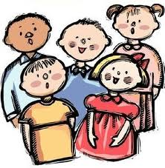
Welcome to Worship at _________ Baptist Church!
As you look around you will notice that our children are important members of our worshipping community. Their presence here grows out of our commitment to incorporate them into the life and mission of our congregation and to nurture them into a growing relationship with Jesus Christ. They are part of our church!
Bringing children to worship will not always be easy – for any of us – but it can be an extremely important part of a child’s spiritual growth. Children begin to learn to worship God by the examples of adults. We trust that, together, we can provide a positive experience for our young worshippers.
For the Congregation:
- Express joy at having children worship with us. Send a smile their way.

- Talk with the children who attend our church each week; make them feel valued and loved.

- Help parents of small children by showing your support for their children who are an integral part of our church family.

Some helpful hints for parents or ‘faith-parents’:
- Bring something soft and quiet for little ones to hold onto or look at. You might have a ‘church-bag’ with special things in it for Sunday’s only.
- Establish positive and negative signals to use during the service, instead of talking.
- Stop at the washroom before the service and sit near the front so kids can see what’s going on.
- Share your Bible and hymnal with your child.
- Go over the order of worship with them – mark the scriptures that will be read in their own Bible.
- Point at the words of hymns and scripture with your finger to help young readers follow along or encourage them to look at the power point screen and follow there.
- Encourage your entire family to stand up and participate in the service together.
- Give your kids some coins to put into the offering. Talk with them about why we give our tithes and offerings to God.
- After worship talk about the service. You might ask, “What is one thing that God taught you at worship today?” Discuss any questions they might have.

