Celebrating Life in Christ!
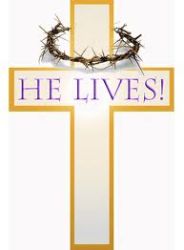

Easter Wall Hanging

Introduction

The high point of the Christian year is Easter. Children not only need to know the story of Jesus’ death and resurrection but they need to understand the implications of it – eternal life through his name! Use this simple tool to create an opportunity for you to read and discuss it with them. Celebrate life in Christ!!

Instructions:

Using the materials provided, create an Easter Wall Hanging with a child who is part of your family or faith family. (Note: For young children it will be best to spread this activity out over several days.)

Read the biblical story to your child from the Bible or use a simple Bible story book

Add the appropriate symbol to your wall hanging using glue. (Note: older children may add their own creative touches to it.)

Finish the wall hanging by tying the ribbon and hanging it on the wall.

Materials provided:

6 coloured cards

Ribbon

Pictures of each symbol

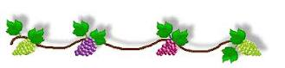

STORY SYMBOL
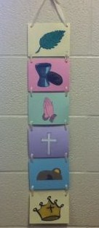

Journey into Jerusalem - Palm Sunday Palm Branch

Matthew 21:1-11

- The Last Supper Bread and Cup
Matthew 26:17-30

Jesus Prays Praying Hands

Matthew 26:36-46

- Jesus Dies on the Cross Cross
Matthew 27:11-61

- Jesus is Resurrected! Empty Tomb
Matthew 28: 1-10

- Jesus ascends into Heaven Crown
Mark 16:9-20

